EC57-K02
Bus-type open-loop and closed-loop stepper drivers

User Manual V1.0.0
Shenzhen GRMOT Technology Co., Ltd.
Table of contents

1. Product Introduction 1
1.1 Product Overview 1
1.2 Product Characteristics 1
1.3 Network Topology 2
2. Installation dimensions and interface definitions 3
2.1Mechanical installation diagram 3
2.2 Installation Precautions 3
2.3 Electrical Specifications 3
2.4 Usage Environment and Parameters 4
3. Driver interface and wiring description 5
3.1 Overview of Driver Interface 5
3.2 DIP switches 5
3.2.1 Open/Closed Loop Mode Settings 6
3.2.2 Current setting 6
3.2.3 Direction Switching Settings 6
3.3 Indicator Lights 6
3.4 Communication Interface 6
3.5 Input signal description and wiring diagram 7
3.6 Output signal description and wiring diagram 8
3.7 Serial Communication Signal Interface 9
3.8 Encoder Input Signal Interface 10
3.9 Motor control output interface 10
3.10 Power Input Interface 10
4. Parameter description and settings 10
4.1 All Parameters 10
4.1.1 Communication Parameters 10
4.1.2 Manufacturer-defined parameters 12
4.1.3 Cia402 Parameter Group 16
4.2 IO Function Configuration 17
4.2.1 Input Signal 17
4.2.2 Output Signal 18
5. Common functions 19
5.1 Parameter saving and factory reset 19
5.2 Definition of Control Word and Status Word Bits 19
5.2.1 6040 control word 19
5.2.2 Status Word 6041 20
5.3 Control Modes and Associated Object Dictionary 20
5.4 State transitions in each control mode 21
5.5 Return to Origin Mode 22
5.5.1 Method 17 (Negative Limit Return to Zero) 23
5.5.2 Method 18 (Positive Limit Return to Zero) 23
5.5.3 Method 19 (Return to Zero 1) 24
5.5.4 Method 20 (Return to Zero 2) 25
5.5.5 Method 21 (Return to Zero 3) 25
5.5.6 Method 22 (Return to Zero 4) 26
5.5.7 Method 23 (Origin + Positive Limit Switch Zeroing 1) 26
5.5.8 Method 24 (Origin + Positive Limit Switch Zeroing 2) 27
5.5.9 Method 25 (Origin + Positive Limit Switch Zeroing 3) 28
5.5.10 Method 26 (Origin + Positive Limit Switch Zeroing 4) 29
5.5.11 Method 27 (Origin + Negative Limit Return to Zero 1) 30
5.5.12 Method 28 (Origin + Negative Limit Return to Zero 2) 31
5.5.13 Method 29 (Origin + Negative Limit Return to Zero 3) 31
5.5.14 Method 30 (Origin + Negative Limit Return to Zero 4) 32
5.5.15 Method 33 (Z signal returns to zero 1) 32
5.5.16 Method 34 (Z signal returns to zero 2) 33
5.5.17 Method -3 (Blocked and then returned to zero 1) 34
5.5.18 Method -4 (Blocked and returned to zero 2) 34
5.5.19 Method -5 (blocked and turned back to zero 3) 34
5.5.20 Method -6 (blocked and turned back to zero 4) 35
5.5.21 Brief Introduction to Other Zero-Return Methods 35
6. Serial port download parameter description 36
7. Fault codes and indicator lights 36
7.1 Driver failure 36
7.2 EtherCAT Communication Alarm 36
8. Warranty and after-sales service 37
8.1 Warranty 37
8.1.1 Free Warranty Status 37
8.1.2 Cases not covered by warranty 37
8.2 Exchange 37
8.2.1 Product replacement due to malfunction 37
8.2.2 Replacement for non-product malfunctions 38
8.3 Returns 38
8.4 After-sales service 39
9. Version Revision History 39

Product Introduction

1.1 Product Overview
The EC57-K02 bus-type open-loop and closed-loop integrated stepper driver adopts an EtherCAT bus communication interface, integrating EtherCAT slave technology, vector control technology, built-in microstepping technology, adaptive filtering technology, and closed-loop control technology to achieve real-time control and data transmission of the stepper system, optimizing the performance of the stepper motor: excellent smoothness and ultra-low noise at low and medium speeds; greatly improved torque at high speeds, expanding the speed application range of the stepper motor; and smooth and precise pure sine current vector control technology effectively reduces motor heat generation.
The EC57-K02 bus-type open-loop and closed-loop integrated stepper driver perfectly supports multiple master station control systems such as Beckhoff, Omron, Zheng Motion, Huichuan, and Xinje, and has been widely used in industries such as textiles, robotics, lithium battery equipment, and 3C electronics.

1.2 Product Characteristics
●New generation 32-bit ARM technology offers excellent cost-effectiveness, superior stability, and excellent noise and vibration performance.
●Employs EtherCAT slave technology, supports CIA301 and CIA402 sub-protocols, and supports CSP, PV, PP, and HM modes.
●Users can set the current, microstepping, and lockout current via EtherCAT bus or serial communication.
●Built-in single-axis controller function: Users can set synchronous position mode, speed mode, position mode, and homing mode via the bus.
●5-channel opto-isolated programmable input interface Receive external control signals, Implement driver limit, Origin, emergency stop, and other functions
●Built-in micro-subdivision
●Built-in motor parameter settings
●The current reduction ratio can be set arbitrarily when the device is stationary.
●Easy current setting
●It has overvoltage and undervoltage protection functions.
●Excellent stability, superior noise and vibration performance.
●Supports position control, Speed ​​control and other modes
●Pure sinusoidal current vector control effectively reduces motor heating.
●3-channel opto-isolated programmable output interface, outputting driver status and control signals.
●It features arbitrary subdivision adjustment, allowing you to freely change the subdivision.
●The closed loop can be set with an out-of-tolerance alarm threshold.
●It exhibits excellent stability at low-frequency, small-scale subdivisions.
●Voltage range: DC 20-50V

1.3 Network Topology
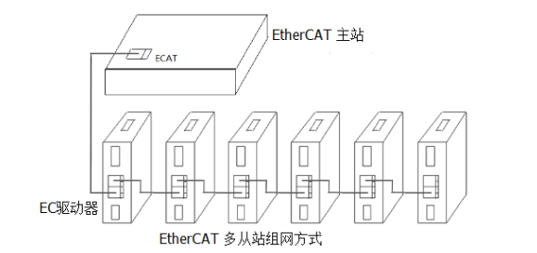
Figure 1. Bus-type stepper network scheme

Installation dimensions and interface definitions

2.1Mechanical installation diagram
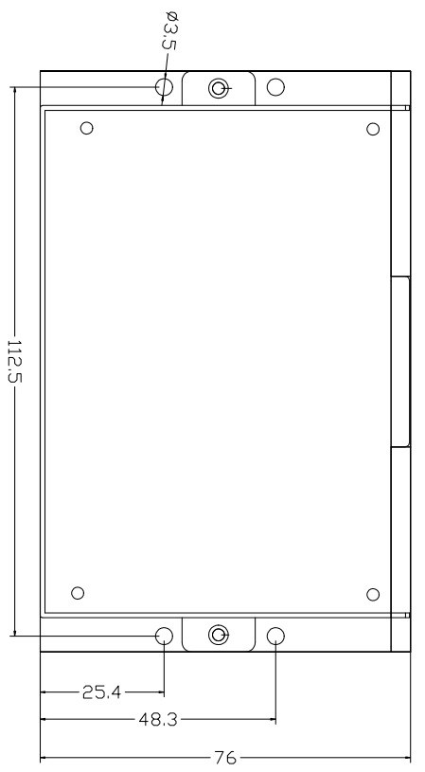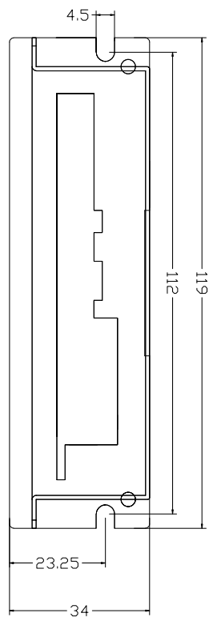
Front installation diagram Side mounting diagram

Figure 2.1 Installation dimensions (unit: mm)

2.2 Installation Precautions
- When installing the driver, please use side mounting for better heat dissipation. When designing the installation dimensions, you need to consider the terminal size and wiring.
- To ensure good heat dissipation, a larger installation interval must be reserved in actual installation. If necessary, a fan can be installed inside the machine near the drive to create strong air convection on the bottom surface of the drive, which helps to dissipate heat from the drive and ensures that the drive operates within a reliable operating temperature range.

2.3 Electrical Specifications
illustrate | EC57-K02 Bus-type Open/Closed-Loop Stepper Driver
illustrate | Minimum value | Typical value | Maximum value | unit
Output current | 0 | - | 6000 | mA
Input power supply voltage | 20 | 36 | 50 | VDC
Control signal input current | 7 | 10 | 16 | mA
Insulation resistance | 50 | - | - | MΩ

2.4 Usage Environment and Parameters
Cooling method |  | Natural cooling, fan cooling
Usage Environment | occasion | Do not place near other heat-generating equipment. Avoid dust, oil mist, corrosive gases, high humidity, and areas with strong vibrations. Keep out of reach of flammable gases and conductive dust.
Usage Environment | temperature | -25℃~55℃
Usage Environment | humidity | 40~90%RH
Usage Environment | vibration | 10~55Hz/0.15mm
Storage temperature |  | -25℃~65℃

Driver interface and wiring description

3.1 Overview of Driver Interface
Table 3.1 Driver Interface
name |  | Function | illustrate
DIP switch SW1-4 |  | Set open/closed loop mode, current, and motor rotation direction. | SW1: Driver Open/Closed Loop Selection
 |  |  | SW2-3: Current Selection
 |  |  | SW4: Direction Switching
ALM |  | Alarm indicator | Overcurrent, overvoltage, phase loss, EEPROM programming error flashing
PWR |  | Power indicator light | The light is on when the power is on normally.
ECAT IN/OUT |  | EtherCAT communication port | ECAT IN: Enter  ECAT OUT: Out
IN/OUT | Xcom | Single-ended input port common terminal  Valid connection | Anode
IN/OUT | Ycom | Single-ended output port common terminal  Compatible with both Yin and Yang | Compatible with both common cathode and common anode connection methods
IN/OUT | X0~X4 | Single-ended input port | Low-speed digital signal input interface
IN/OUT | Y0~Y2 | Single-ended output port | Low-speed digital signal output interface
UART | 3.3V | Serial communication | Serial port download COE parameters
UART | GND | Serial communication | Serial port download COE parameters
UART | RXD | Serial communication | Serial port download COE parameters
UART | TXD | Serial communication | Serial port download COE parameters
ENCODER | ENZ+ | Encoder Interface | Z signal level detection
ENCODER | ENB+ | Encoder Interface | Z signal level detection
ENCODER | ENB- | Encoder Interface
ENCODER | ENA+ | Encoder Interface
ENCODER | ENA- | Encoder Interface
ENCODER | VCC | Encoder Interface
ENCODER | GND |  | Encoder 5V power supply negative terminal
ENCODER | A+
 | A-
 | B+
 | B-
 | VDC
 | GND

3.2 DIP switches
Table 3.2 Description of DIP Switch Functions
name | Function | illustrate
DIP switches SW1-SW4 | Set open/closed loop mode, current, and motor rotation direction. | SW1: Driver Open/Closed Loop Selection
DIP switches SW1-SW4 |  | SW2-SW3: Current Selection
DIP switches SW1-SW4 |  | SW4: Direction Switching

3.2.1 Open/Closed Loop Mode Settings
The open-loop and closed-loop modes can be selected via DIP switch SW1, as shown in the table below.
Table 3.3 Open-loop and closed-loop mode settings
SW1 | Work mode
off | Open loop
on | closed loop

3.2.2 Current setting
In both open-loop and closed-loop modes, the current can be set via DIP switches SW2-SW3, offering four selectable current levels compatible with motors ranging from 42 to 86. If the user needs to adjust the current manually, this can be done through the host computer software or the ECAT master station.SW2-SW3 must be switched to the off position before adjustment can be made.
Table 3.4 Current Magnitude Settings
SW2 | SW3 | Open loop |  | closed loop
SW2 | SW3 | Peak | RMS | Imin | Imax
off | off | 1.0 | 0.7 | 0.2 | 0.7
on | off | 2.1 | 1.5 | 0.3 | 1.2
off | on | 4.2 | 3.0 | 0.5 | 2.5
on | on | 5.6 | 4.0 | 1.0 | 4.8

3.2.3 Direction Switching Settings
Users can select the initial rotation direction of the motor using DIP switch SW4.As shown in the table below.
Table 3.5 Direction Switching Settings
SW4 | Initial rotation direction
off | Positive direction
on | opposite direction

3.3 Indicator Lights
EC57-K02 Bus-type Open/Closed-Loop Integrated Stepper DriverThe indicator light is a recessed surface-mount LED. There is a small cutout on the driver to observe the status of the indicator light. Its basic definition is shown in Table 3.6 below.
Table 3.6 Indicator Light Definitions
name | describe | Function | illustrate
ALM | Red LED | Power indicator, save parameter function indicator, factory reset function indicator, DIP switch status switching indicator.  Alarm indicator light | When the power is on normally, the green light is always on and the red light is off.  When saving parameters, restoring factory settings, switching DIP switch states, or when the device malfunctions, the red light will flash as an alarm. See Chapter 7 for the flashing pattern.
PWR | Green LED

3.4 Communication Interface
EC57-K02 Bus-type Open/Closed-Loop Integrated Stepper DriverThe communication interface uses a one-piece standard RJ45 socket, as shown in Figure 3.1. The left port is the input terminal, connected to the output terminal of the previous driver; the right port is the output terminal, connected to the input terminal of the next driver.
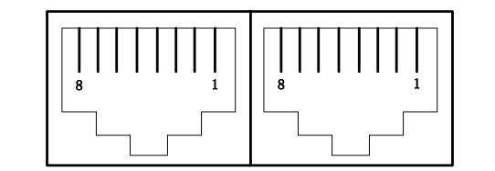

Figure 3.1 Schematic diagram of integrated RJ45 interface

3.5 Input signal description and wiring diagram
EC57-K02 Bus-type Open/Closed-Loop Integrated Stepper DriverIt provides a programmable interface with opto-isolation for the input.
The input interface adopts a common anode connection and only supports NPN wiring. It is connected to an external +24V. To ensure reliable conduction of the internal optocoupler of the driver, the drive current at the controller end must be at least 10mA and the input level pulse width must be greater than 10ms. Otherwise, the driver may not be able to respond normally. The wiring diagram is shown in Figures 3.2 and 3.3.
After the driver is powered on normally, the initial valid level of the input interface is either a rising edge or a high level.Users can also configure the effective level of the input interface through the main station. The initial default value is either a falling edge or a low level. For specific configuration, please refer to the definition and description of the registers in section 4.2.
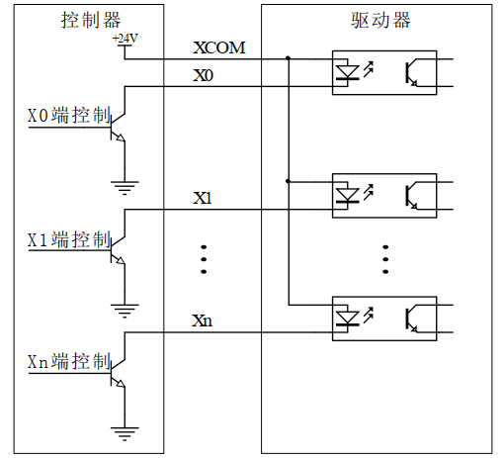
Figure 3.2 Schematic diagram of input signal wiring
Taking an NPN sensor as an example, the wiring diagram for connecting it to the X0 terminal of the driver is as follows:
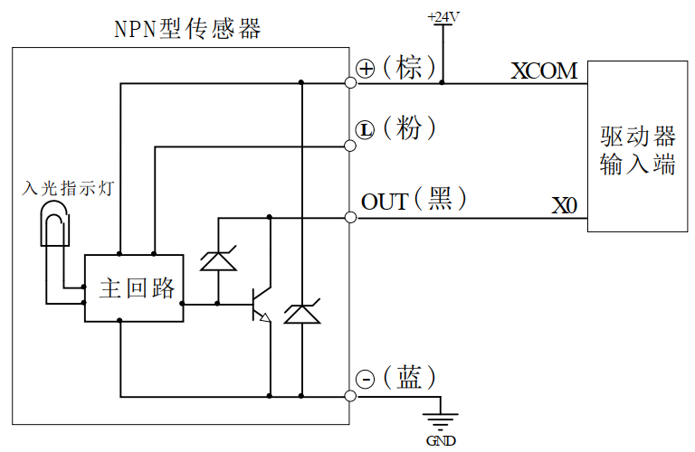
Figure 3.3 Wiring diagram of NPN type sensor
Note: The EC57-K02 bus-type open-loop integrated stepper driver supports a 24V signal by default. If the user requires 5V signal control, the user needs to communicate with our sales or technical personnel to make the necessary changes.

3.6 Output signal description and wiring diagram
EC57-K02 Bus-type Open/Closed-Loop Integrated Stepper DriverIt provides a programmable interface with opto-isolation for the output.
The output interface is compatible with common cathode and common anode connections, supporting both NPN and PNP wiring methods, and can support master station controllers that are active high or low.
After the driver is powered on normally, the initial default valid state of the output interface is normally open output.Users can also configure the valid state of the output interface through the main station. The initial default is normally closed output. For specific configuration, please refer to the definition and description of the internal registers in Chapter 4.2.
The following diagram shows the wiring schematic for the output signal interface:
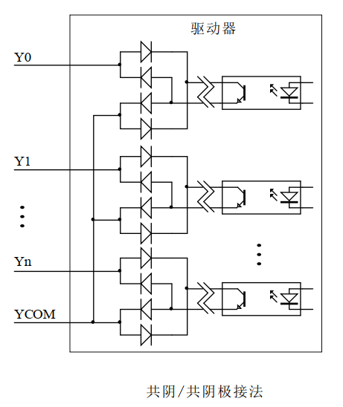
Figure 3.4 Schematic diagram of output signal wiring

3.7 Serial Communication Signal Interface
name |  | illustrate | Function
UART | RXD | Serial communication interface | When connecting to the serial communication interface, it needs to be cross-connected with the external serial signal cable.
UART | TXD | Serial communication interface
UART | 3.3V | Serial communication power interface | 3.3V power supply positive terminal
UART | GND | Serial communication power interface | 3.3V power supply negative terminal

3.8 Encoder Input Signal Interface
name |  | illustrate | Function
Encoder | ENZ+ | Encoder Interface | Connect the encoder A, B, and Z signals, paying attention to the wiring sequence.
Encoder | ENZ- | Encoder Interface
Encoder | ENB+ | Encoder Interface
Encoder | ENB- | Encoder Interface
Encoder | ENA+ | Encoder Interface
Encoder | ENA- | Encoder Interface
Encoder | VCC | Encoder power interface | Encoder 5V power supply positive terminal
Encoder | GND | Encoder power interface | Encoder 5V power supply negative terminal

3.9 Motor control output interface
name |  | illustrate | Function
Motor | A+ | Motor interface | Two-phase stepper motor wiring port  If it is a closed-loop motor, pay attention to the wiring sequence.
Motor | A- | Motor interface
Motor | B+ | Motor interface
Motor | B- | Motor interface

3.10 Power Input Interface
name |  | illustrate | Function
VDC | VDC | Power interface | Power input  DC20V~50V
VDC | GND | Power interface | Power input  DC20V~50V

Parameter description and settings

4.1 All Parameters

4.1.1 Communication Parameters
index | Sub-index | name | illustrate | type | property | default value | scope
1000 | 0 | Equipment type | Consistent with CIA rules | UINT32_t | RO | 0x04020192 | 0~0xFFFFFFFF
1001 | 0 | Error Register |  | UINT8_t | RO | 0 | 0~255
1008 | 0 | Equipment Name | Mainly product screen printing | str | RO | EC57-K02 | 0~32767
1009 | 0 | Hardware version | PCB board version | str | RO | - | 0~32767
100A | 0 | Software version | Version of the burning program | str | RO | - | 0~32767
1010 | 00 | Number of sub-indexes | . | UINT16_t | RO | 4 | 0~32767
1010 | 01 | Save all parameters | Save command: 0x65766173 | UINT32_t | RW | 0 | 0~0xFFFFFFFF
1010 | 02 | Save communication parameters | Same as above | UINT32_t | RW | 0 | 0~0xFFFFFFFF
1010 | 03 | Save manufacturer parameters | Same as above | UINT32_t | RW | 0 | 0~0xFFFFFFFF
1010 | 04 | Save motion parameters | Same as above | UINT32_t | RW | 0 | 0~0xFFFFFFFF
1011 | 0 | Number of sub-indexes | . | UINT16_t | RO | 4 | 0~32767
1011 | 01 | Restore all parameters to factory settings | Read command: 0x64616f6c | UINT32_t | RW | 0 | 0~0xFFFFFFFF
1011 | 02 | Restore communication parameters to factory settings | Same as above | UINT32_t | RW | 0 | 0~0xFFFFFFFF
1011 | 03 | Restore motion parameters to factory settings | Same as above | UINT32_t | RW | 0 | 0~0xFFFFFFFF
1011 | 04 | Restore user parameters to factory settings | Same as above | UINT32_t | RW | 0 | 0~0xFFFFFFFF
1018 | 00 | Number of sub-indexes | . | UINT16_t | RO | 4 | 0~32767
1018 | 01 | Manufacturer ID | Supplier ID | UINT32_t | RO | - | 0~0xFFFFFFFF
1018 | 02 | Product Code |  | UINT32_t | RO | 0x69673537 | 0~0xFFFFFFFF
1018 | 03 | Modify encoding |  | UINT32_t | RO | - | 0~0xFFFFFFFF
1018 | 04 | Serial Number |  | UINT32_t | RO | - | 0~0xFFFFFFFF
1600 | 00 | Number of sub-indexes | The default number of PDO mapped objects | UINT16_t | RW | 3 | 0~32767
1600 | 01-08 | RXPDO mapping object group 1 | The default RXPDO mapping object | UINT32_t | RW | . | 0~0xFFFFFFFF
1601 | 00 | Number of sub-indexes | The default number of PDO mapped objects | UINT16_t | RW | 6 | 0~32767
1601 | 01-08 | RXPDO mapping object group 2 | The default RXPDO mapping object | UINT32_t | RW | . | 0~0xFFFFFFFF
1602 | 00 | Number of sub-indexes | The default number of PDO mapped objects | UINT16_t | RW | 5 | 0~32767
1602 | 01-08 | RXPDO mapping object group 3 | The default RXPDO mapping object | UINT32_t | RW | . | 0~0xFFFFFFFF
1603 | 0 | Number of sub-indexes | The default number of PDO mapped objects | UINT16_t | RW | 7 | 0~32767
1603 | 01-08 | RXPDO mapping object group 4 | The default RXPDO mapping object | UINT32_t | RW | . | 0~0xFFFFFFFF
1A00 | 0 | Number of sub-indexes | The default number of PDO mapped objects | UINT16_t | RW | 6 | 0~32767
1A00 | 01-08 | TXPDO mapping object group 1 | The default TXPDO mapping object | UINT32_t | RW | . | 0~0xFFFFFFFF
1A01 | 0 | Number of sub-indexes | The default number of PDO mapped objects | UINT16_t | RW | 5 | 0~32767
1A01 | 01-08 | TXPDO mapping object group 2 | The default TXPDO mapping object | UINT32_t | RW | . | 0~0xFFFFFFFF
1C00 | 00 | Number of sub-indexes |  | UINT16_t | RO | 4 | 0~32767
1C00 | 01 | Email output type |  | UINT8_t | RO | 1 | 0~255
1C00 | 02 | Email input type |  | UINT8_t | RO | 2 | 0~255
1C00 | 03 | Process data output type |  | UINT8_t | RO | 3 | 0~255
1C00 | 04 | Process data input type |  | UINT8_t | RO | 4 | 0~255
1C12 | 0-04 | PXPDO allocation |  | UINT16_t | RW | 1600 | 0~32767
1C13 | 0-02 | TXPDO allocation |  | UINT16_t | RW | 1A00 | 0~32767
1C32 | 0-0A | RXPDO Management Parameters |  | UINT16_t | RO | . | 0~32767
1C33 | 0-0A | TXPDO Management Parameters |  | UINT16_t | RO | . | 0~32767

4.1.2 Manufacturer-defined parameters
index | Sub-index | name | illustrate | type | property | default value | scope
2000 | 0 | From station address | Set the slave address via serial port;  Note the settings for 2001H; | UINT16_t | R/W/S | 1 | 0~65535
2001 | 0 | Source of website address | 0: Originated from the main site's assigned address; 1: Originated from the 2000H setting address. | UINT16_t | R/W/S | 0 | 0~1
2002 | 0 | Open-loop and closed-loop motor running direction | When SW4 is OFF, the initial running direction of the motor can be set through the master station;  0: Motor running direction remains unchanged; 1: Motor direction is reversed. | UINT16_t | R/W/S | 0 | 0~1
2003 | 1 | Loop lock machine current reduction time | After stopping operation, the flow reduction time  Unit: ms | UINT16_t | R/W/S | 500 | 10~3000
2003 | 2 | Percentage of current reduction in the open-loop lock machine | After stopping operation, the percentage of the lock current.  unit:% | UINT16_t | R/W/S | 50 | 0~100
2004 | 0 | Open-loop peak current setting | When SW2-SW3 are all OFF, the open-loop peak current can be set through the master station.  Unit: mA | UINT16_t | R/W/S | 1400 | 100~7000
2005 | 0 | Open-loop and closed-loop subdivision settings | The number of pulses required for one revolution;  Unit: Pul/rev | UINT16_t | R/W/S | 10000 | 6400~51200
2006 | 0 | Enable the opening and closing loop lock machine  set up | 0: Unlocked 1: Locked | UINT16_t | R/W/S | 0 | 0~1
2007 | 0 | Current loop self-tuning enable | Current loop PI power-on self-tuning function: 0: Enable  1: Do not enable | UINT16_t | R/W/S | 0 | 0~1
2008 | 0 | Open-loop and closed-loop current loops KP | When self-tuning is enabled, this item is read-only;  When disabled, the user can rewrite | UINT16_t | R/W/S | 6000 | 50~32767
2009 | 0 | Open-loop and closed-loop current loops KI | When self-tuning is enabled, this item is read-only;  When disabled, the user can rewrite | UINT16_t | R/W/S | twenty four | 10~2000
200A | 0 | Open-loop and closed-loop current loop Kc | Automatically retrieved; customer modification not allowed. | UINT16_t | R/S | - | 0~32767
200B | 0 | Open-loop power-on lock shaft duration | Unit: ms | UINT16_t | R/W/S | 50 | 10~3000
200C | 0 | Open-loop power-on lock shaft duration selection | 0: Default lock duration  1:200BH setting duration | UINT16_t | R/W/S | 0 | 0~1
200D | 0 | bus voltage | Unit: mV | UINT16_t | R | - | 0~65535
200E | 0 | Over-tolerance alarm enable | 0: Disable out-of-tolerance alarm; 1: Enable out-of-tolerance alarm. | UINT16_t | R/W/S | 1 | 0~1
200F | 0 | Out-of-tolerance alarm value | Set the out-of-tolerance alarm angle value  1 represents 0.09°, and 1000 represents 90°. | UINT16_t | R/W/S | 1000 | 0~4000
2010 | 0 | Total number of external locations H | Received location command accumulated value  High 16 bits (reserved for now) | UINT16_t | R | 0 | 0~65535
2011 | 0 | Total number of external locations L | Received location command accumulated value  Lower 16 bits (reserved for now) Note: Write 1 to clear the counter. | UINT16_t | R/W | 0 | 0~65535
2012 | 0 | Speeding limit | Used to determine whether the speed of the received command exceeds the speed limit;  Unit: revolutions per minute | UINT16_t | R/W | 3000 | 0~3000
2013 | 0 | Automatic positioning upon power-on | 0: Normal standby mode after power-on. 1: After power-on, the motor rotates 30° clockwise, then 15° counter-clockwise to enter standby mode. | UINT16_t | R/W/S | 0 | 0~1
2014 | 0 | Input I/O status | bit0 corresponds to the state of input port X0, bit1 corresponds to the state of input port X1, and so on. | UINT16_t | R | - | 0~65535
2015 | 0 | FIR filter enable | 0: No filtering, 1: Filtering  (To be reserved for now) | UINT16_t | R/W/S | 0 | 0~1
2016 | 0 | FIR filter time constant | Unit: ms  (To be reserved for now) | UINT16_t | R/W/S | 0 | 50~25600
2017 | 0 | Real speed reference value | Corresponding object dictionary 0x606C | UINT16_t | R | 0 | 0~32767
2018 | 0 | Position error value | Encoder deviation value | INT16_t | R | 0 | -32767~32767
2019 | 0 | Open-loop and closed-loop mode switching | When SW1 is OFF, the open/closed loop mode can be switched via the main station;  0: Open-loop control  1: Closed-loop control | UINT16_t | R/W/S | 0 | 0~32767
201A | 1 | Driver software version |  | UINT16_t | R | - | 0~32767
201A | 2 | Hardware version |  | UINT16_t | R | - | 0~32767
201A | 3 | Bus hierarchy software version |  | UINT16_t | R | - | 0~32767
201B | 0 | Fault detection enable configuration | Software fault detection enable configuration; bit 0: overcurrent; bit 1: overvoltage; bit 2: EEPROM; bit 3: instruction overspeed; bit 11: op-amp fault.  0: Disable this fault detection  1: Enable corresponding fault detection | UINT16_t | R/W/S | 15 | 0~65535
201C | 1 | Fault List 1 | The most recent alarm record; all others are historical alarm records. | UINT16_t | R | - | 0~65535
201C | 2 | Fault List 2 | A previous alarm in fault list 1 | UINT16_t | R | - | 0~65535
201C | 3 | Fault List 3 | A previous alarm in fault list 2 | UINT16_t | R | - | 0~65535
201C | 4 | Fault List 4 | A previous alarm in fault list 3 | UINT16_t | R | - | 0~65535
201C | 5 | Fault List 5 | A previous alarm in fault list 4 | UINT16_t | R | - | 0~65535
201C | 6 | Fault List 6 | A previous alarm in fault list 5 | UINT16_t | R | - | 0~65535
201C | 7 | Fault List 7 | A previous alarm in fault list 6 | UINT16_t | R | - | 0~65535
201C | 8 | Fault List 8 | A previous alarm in the fault list 7 | UINT16_t | R | - | 0~65535
201C | 9 | Fault List 9 | A previous alarm in the fault list 8 | UINT16_t | R | - | 0~65535
201D | 0 | Clear fault log enable bit selection | 0: Do not clear historical fault records  1: Clear historical fault records | UINT16_t | R/W | 0 | 0~1
201E | 0 | Clear current fault enable bit selection | 0: Do not clear the current fault.  1: Clear the current fault | UINT16_t | R/W | 0 | 0~1
201F | 0 | Reasons why the motor is not working  Query | 0x2: Instruction overspeed | UINT16_t | R | - | 0~32767
2020 | 0 | Mode 1 Query | 0: Planning complete, in place. 10: Arrival signal originates from the drive. | UINT16_t | R | - | 0~32767
2021 | 0 | Input digital I/O port level polarity configuration | bit0: Polarity of input port X0  bit1: Polarity of input port X1  And so on;  bit5-bit15: Reserved  And so on.  0: unchanged; 1: inverted | UINT16_t | R/W/S | 0 | 0~65535
2022 | 1 | Input digital I/O port X0 function definition | Default: Negative limit | UINT16_t | R/W/S | 4 | 0~255
2022 | 2 | Input Digital I/O Port X1 Function Definition | Default: Positive limit | UINT16_t | R/W/S | 2 | 0~255
2022 | 3 | Input Digital I/O Port X2 Function Definition | Default: Origin signal | UINT16_t | R/W/S | 1 | 0~255
2022 | 4 | Input Digital I/O Port X3 Function Definition | Default: Fast stop | UINT16_t | R/W/S | 8 | 0~255
2022 | 5 | Input Digital I/O Port X4 Function Definition | Default: Reserved | UINT16_t | R/W/S | 0 | 0~255
2023 | 1~5 | Input digital I/O port X0~X4 filtering time | Set the filtering time for input ports X0-X4;  Unit: us | UINT16_t | R/W/S | 1000 | 50~60000
2024 | 0 | Output port polarity configuration | bit0: Output port Y0 polarity  bit1: Polarity of output port Y1  bit2: Polarity of output port Y2  bit3-bit15: Reserved  0: Low level 1: High level  See detailschapter'3.2.2 Output Signal'Description within; | UINT16_t | R/W/S | 0 | 0~65535
2025 | 1 | Output port Y0 function settings | Each bit of the sub-index corresponds to a function selection. For example, if output port Y0 is set to bit output function, then the value of 2025:1 is set to 0x0001.  bit0: Alarm output; bit1: Position output  bit2: Z signal output; bit4: Master station control output (default)  bit3, bit5-bit15: Reserved  See detailschapter'3.2.2 Output Signal'Description within; | UINT16_t | R/W/S | 16 | 0~255
2025 | 2 | Output port Y1 function settings |  | UINT16_t | R/W/S | 16 | 0~255
2025 | 3 | Output port Y2 function settings |  | UINT16_t | R/W/S | 16 | 0~255
2030 | 0 | Save/Restore  Manufacturer parameters | bit0: Save manufacturer parameters bit1: Restore manufacturer parameters to factory settings  Note: This is for serial port download parameters only.  This parameter is not available in COE. | UINT16_t | W/S | 0 | 0~255

4.1.3 Cia402 Parameter Group
index | Sub-index | name | illustrate | type | property | default value | scope
603F | 0 | Fault codes | See chapter for details'V. Fault Code Explanation'Description within; | UINT16_t | RO | - | 0~65535
6040 | 0 | control word | See chapter for details'6.3.1 6040 control word'Description within; | UINT16_t | RW | 0 | 0~65535
6041 | 0 | status word | See chapter for details'6.3.2 Status Word 6041'Description within; | UINT16_t | RO | - | 0~65535
605A | 0 | Quick stop code | 0: Invalid  1: Emergency Stop Permission | UINT16_t | RW | 1 | 0~65535
6060 | 0 | Running mode settings | 1: PP (Position Mode)  3: PV (Speed ​​Mode)  6: HM (Back to Origin Mode)  8: CSP (Cyclic Synchronous Position Mode) | USINT | RW | 8 | 0~255
6061 | 0 | Operating mode status | Check the status of 6060H;  1: PP (Position Mode)  3: PV (Speed ​​Mode)  6: HM (Return to Remote Point Mode)  8: CSP (Cyclic Synchronous Position Mode) | USINT | RO | - | 0~255
6064 | 0 | actual location | Actual position of motor, unit: Pul | DINT | RO | - | -2147483647~  2147483647
606C | 0 | actual speed | Current motor speed, unit: Pul/s | DINT | RO | - | -2147483647~  2147483647
607A | 0 | Target location | Set the total number of pulses for PP (position mode) operation;  Unit: pul | DINT | RW | 0 | -2147483647~  2147483647
607C | 0 | Origin offset | Set the origin offset for HM (Back to Origin Mode);  Unit: Pul | DINT | RW | 0 | -2147483647~  2147483647
60FF | 0 | Target speed | Set the maximum speed for PV (Speed ​​Mode);  Unit: Pul/s | DINT | RW | 0 | -2147483647~  2147483647
6081 | 0 | Trapezoidal velocity | Set the maximum speed for PP (position mode);  Unit: Pul/s | DINT | RW | 50000 | -2147483647~  2147483647
6082 | 0 | Start and end speeds | Set the start and stop speeds of PP (position mode);  Unit: Pul/s | DINT | RW | 0 | -2147483647~  2147483647
6083 | 0 | acceleration | Set the acceleration for PP (position mode) and PV (velocity mode);  Unit: Pul/s^2 | DINT | RW | 500000 | -2147483647~  2147483647
6084 | 0 | deceleration | Set the deceleration for PP (position mode) and PV (speed mode);  Unit: Pul/s^2 | DINT | RW | 500000 | -2147483647~  2147483647
6085 | 0 | Emergency stop deceleration | Set the emergency stop deceleration for PP (position mode), PV (speed mode), and HM (return to origin mode);  Unit: Pul/s^2 | DINT | RW | 5000000 | -2147483647~  2147483647
6098 | 0 | Return to origin method | The currently available values ​​for the return-to-origin method are: (-1)~(-6), 1~14, 17~30, 33, 34, 35, 37;  See chapter for details'5.5 Return to Origin Mode Method'Description within; | SUINT | RW | 0 | 0~255
6099 | 01 | Origin-finding speed 1 | HM (Return to Origin Mode) Origin Finding Speed ​​1: High-speed origin finding;  Unit: Pul/s | DINT | RW | 50000 | -2147483647~  2147483647
6099 | 02 | Origin-finding speed 2 | HM (Return to Origin Mode) Origin Finding Speed ​​2: Low-speed origin finding;  Unit: Pul/s | DINT | RW | 25000 | -2147483647~  2147483647
609A | 0 | Acceleration and deceleration at the origin | HM (Homeward Bound Mode) homeward acceleration and deceleration;  Unit: Pul/s^2 | DINT | RW | 25000 | -2147483647~  2147483647
60FD | 0 | Input I/O status | bit0 corresponds to the state of input port X0, bit1 corresponds to the state of input port X1, and so on;  See detailschapter'3.2.1 Input Signal'Description within;  Notice:The newly added bit 31 indicates the input status of the Z signal; | UDINT | RO | - | 0~4294967296
60FE | 1 | Physical output enabled | Output port function enabled;  bit0: Enable output on port Y0  bit1: Enable output on port Y1  bit2: Enable output on port Y2  bit3-bit15: Reserved  0: Invalid output  1: Output valid | UDINT | RW | 0 | 0~4294967296
60FE | 2 | Physical output enable | Output port function enabled;  bit0: Enable output of port Y0  bit1: Enable output of port Y1  bit2: Enable output of port Y2  bit3-bit15: Reserved  0: Output disabled  1: Output Enable | UDINT | RW | 7 | 0~4294967296

4.2 IO Function Configuration

4.2.1 Input Signal
Input portThe functions and settings of X0-X4 are as follows:
Input port | Function definition | I/O port status query  Object dictionary used 1 | I/O port status query  Object dictionary used 2
X0 | negative limit | 60FD-bit0 | 2014-bit0
X1 | Positive limit switch | 60FD-bit1 | 2014-bit1
X2 | origin signal | 60FD-bit2 | 2014-bit2
X3 | Quick stop signal | 60FD-bit3 | 2014-bit3
X4 | reserve | 60FD-bit4 | 2014-bit4
Brief explanation:
(1) 2022:01 represents the object dictionary 0x2022, sub-index 01 register; others follow the same pattern;
- The status of the input ports can be queried through the object dictionary 0x60FD. For example, when input X0 is valid, bit 0 of 0x60FD becomes 1. The status of input ports X1-X4 corresponds to bits 1-4 of 0x60FD, respectively.
Notice:
(1) Bit 31 of 0x60FD represents the input state of the Z signal. The meaning of each bit of 0x2014 is the same as that of 0x60FD, except for bit 31.
The dictionary of objects related to the input port function configuration is listed in the table below. For details, please refer to the description in section '3.1 All Parameters'.
Input port | Polarity configuration | Filtering time settings | I/O port status query  Object dictionary used 1 | I/O port status query  Object dictionary used 2
X0 | 2021-bit0 | 2023:01 | 60FD-bit0 | 2014-bit0
X1 | 2021-bit1 | 2023:02 | 60FD-bit1 | 2014-bit1
X2 | 2021-bit2 | 2023:03 | 60FD-bit2 | 2014-bit2
X3 | 2021-bit3 | 2023:04 | 60FD-bit3 | 2014-bit3
X4 | 2021-bit4 | 2023:05 | 60FD-bit4 | 2014-bit4

4.2.2 Output Signal
The output ports include alarm output, position output, Z signal output, and master station control output (user-defined). The function of each output port can be selected through the object dictionary 0x2025. The table below describes the default output functions and settings of Y0-Y2.
Output port | Default features | Function selection  object dictionary | Function selection object dictionary default settings | I/O port status query  Object dictionary used 1 | I/O port status query  Object dictionary used 2
Y0 | Master station control output | 2025:01 | 16 | 60FD-bit0 | 2014-bit0
Y1 | Master station control output | 2025:02 | 16 | 60FD-bit1 | 2014-bit1
Y2 | Master station control output | 2025:03 | 16 | 60FD-bit2 | 2014-bit2
The table below uses port Y0 as an example to explain which bit setting corresponds to each output function.
Y0 Port Function Selection | Function selection at 2025:01
Alarm output | 1
Output in place | 2
Z signal output | 4
Master station control output | 16
The dictionary of objects related to the output port function configuration is listed in the table below. For details, please refer to the description in section '3.1 All Parameters'.
Output port | Polarity configuration | Function selection control | Physical output enabled | Physical output enable  60fe+02
Y0 | 2024-bit0 | 2025:01 | 60FE:01-bit0 | 60FE:02-bit0
Y1 | 2024-bit1 | 2025:02 | 60FE:01-bit1 | 60FE:02-bit1
Y2 | 2024-bit2 | 2025:03 | 60FE:01-bit2 | 60FE:02-bit2
For example, to set Y2 to a custom output function, the steps are as follows:
(1) First set the value of sub-index 03 of 0x2025 to 16 (user-defined output function);
(2) Set 60FE:01 and 60FE:02 to 4. At this time, Y2 outputs a signal.

Common functions

5.1 Parameter saving and factory reset
Towards0x1010Corresponding sub-index write command0x65766173The corresponding category parameters can be saved toEEPROMMiddle; towards0x1011Corresponding sub-index write command0x64616f6cThis can restore the factory settings of the corresponding parameter category. After writing the save command, do not turn off the power immediately, especially when saving all parameters. Wait for the 'red indicator light' to go out before turning off the power to ensure that all parameters are saved successfully.
Function | object dictionary | Order | Result Status | Remark
Save Cia402 series parameters | 1010:04 | 0x65766173 | Return 1
Save manufacturer-defined parameters | 1010:03 | 0x65766173 | Return 1
Save communication parameters | 1010:02 | 0x65766173 | Return 1
Save all parameters | 1010:01 | 0x65766173 | Return 1 | The serial port is a button for saving parameters.
Restore Cia402 series parameters | 1011:04 | 0x64616f6c | Return 1
Restore manufacturer-defined parameters | 1011:03 | 0x64616f6c | Return 1
Restore communication parameters | 1011:02 | 0x64616f6c | Return 1
Restore all series parameters | 1011:01 | 0x64616f6c | Return 1 | The serial port is a button for restoring parameters.

5.2 Definition of Control Word and Status Word Bits

5.2.1 6040 control word
Bit | 0 | 1 | 2 | 3 | 4-6 | 7 | 8 | 9-15
Function | start up | powered by | Emergency stop | Enable operation | Operating mode related | Reset error | pause | -
Additional notes for other positions:
Bit 2: The quick stop trigger logic is valid when 0 is active. Note that this should be distinguished from other trigger logic.
Bit 7: Error reset trigger logic is active on the rising edge.
Bit 5: Immediate trigger logic is valid on the rising edge.

5.2.2 Status Word 6041
Bit | 0 | 1 | 2 | 3 | 4 | 5 | 6 | 9 | 11 | 7, 8, 10..
Function | Ready to start | start up | Allow operation | mistake | Power on | Quick stop | Not started | remote | Limiting effective | Pattern related
Additional notes for other positions:
After the driver is powered on 4. Set the bit.
Bit 5: Quickly stop activation. In logic It is only effective when the value is 0, which is the opposite of the logic of other bits.
Bit 9: Remote, displays the communication status machine status. exist ProOP is below 0. At this time, the command of control word (6040h) will not be able to be executed.
Bit 11: Limit bit, set only when the hardware limit is active.
Bit 8: Abnormal stop, generally due to hardware limit switches. Effective during deceleration stop and rapid stop trigger states.
Position 12: Follow the main site, in In CSP, if the driver is not enabled or no longer follows the master station's commands, this location... 0.
Bit 10: with Bits 1 and 5 are set simultaneously, indicating that the origin has been found.

5.3 Control Modes and Associated Object Dictionary
Control Mode | Index + Sub-index | name | Data types | Read and write permissions | unit
Synchronous Position Mode (CSP) | 6040 | control word | UINT16_t | RW | -
Synchronous Position Mode (CSP) | 607A | Target location | DINT | RW | Pul
Synchronous Position Mode (CSP) | 6041 | status word | UINT16_t | RO | -
Synchronous Position Mode (CSP) | 6064 | actual location | DINT | RW | Pul
Synchronous Position Mode (CSP) | 606C | actual speed | DINT | RW | Pul/s
Position mode (PP) | 607A | Target location | DINT | RW | Pul
Position mode (PP) | 6081 | Maximum speed | DINT | RW | Pul/s
Speed ​​Mode (PV) | 60FF | Target speed | DINT | RW | Pul/s
Speed ​​Mode  Location mode  public | 6040 | control word | UINT16_t | RW | -
Speed ​​Mode  Location mode  public | 6083 | acceleration | DINT | RW | Pul/s^2
Speed ​​Mode  Location mode  public | 6084 | deceleration | DINT | RW | Pul/s^2
Return to Origin Mode (HM) | 6040 | control word | UINT16_t | RW | -
Return to Origin Mode (HM) | 6098 | Zeroing method | SUINT | RW | -
Return to Origin Mode (HM) | 6099:01 | Origin-finding speed 1 | DINT | RW | Pul/s
Return to Origin Mode (HM) | 6099:02 | Origin-finding speed 2 | DINT | RW | Pul/s
Return to Origin Mode (HM) | 609A | Origin acceleration | DINT | RW | Pul/s^2
Return to Origin Mode (HM) | 607C | Origin offset | DINT | RW | Pul
There are PV, PP, and HM modes.6041 | status word | UINT16_t | RO | -
There are PV, PP, and HM modes.6041 | 6064 | actual location | DINT | RW | Pul
There are PV, PP, and HM modes.6041 | 606C | actual speed | DINT | RW | Pul/s
Other related parameters | 60FD | Numeric input | UINT16_t | RO | -
Other related parameters | 603F | Latest error code | UINT16_t | RO | -
Other related parameters | 6060 | Running mode settings | SUINT | RW | -
Other related parameters | 6082 | Take-off speed | DINT | RW | Pul/s
Other related parameters | 6085 | Emergency stop deceleration | DINT | RW | Pul/s^2
Other related parameters | 6061 | Operating mode status | SUINT | RO | -
Regardless of the control mode used to control the slave station, reading and writing operations to the two object dictionaries, 6040H (control word) and 6041H (status word), are essential. The master and slave stations use these two object dictionaries as transmission media to issue commands and monitor status. The following sections focus on the definition and meaning of each bit in these two object dictionaries.

5.4 State transitions in each control mode
 | step | 0 | 1 | 2 | 3 | 4 | 5 | 6 | 7 | 8
model | action | Preparatory work | initial | Get electricity | start up | Enable | Start running | Displacement | stop | Fault
CSP mode6040 | Establish communication OP state and activate NC axis | 00h | 06h | 07h | 0Fh | 1F main station sends commands | Master station control | Master station stop position command | -
CSP mode6040 | 6041 | 00h | 250h | 231h | 233h | 1237h | 1237h | 1237h | 1237h | 238h
PP mode6040 | Establish communication OP state and set motion parameters | 00h | 06h | 07h | 0Fh | - | 2Fh~3Fh | 10Fh | -
PP mode6040 | 6041 | 00h | 250h | 231h | 233h | 8237h | 1237h | 1237h | 1637~  1237h | 1238h
PV mode6040 | Establish communication OP state and set motion parameters | 00h | 06h | 07h | 0Fh | Runs after enabling | Simply change the speed. | 10Fh | -
PV mode6040 | 6041 | 00h | 250h | 231h | 233h | 1637h | 1637h | 1637h | 1737h | 1638h
HM mode | 6040 | Establish communication OP state and set motion parameters | 00h | 06h | 07h | 0Fh | 1Fh | invalid | 10Fh | -
HM mode | 6041 | Establish communication OP state and set motion parameters | 250h | 231h | 233h | 8337h | 237h | 237h | 737h | 238h
Additional notes for other bits: When changing the position in PP mode, the control word needs to be provided. A new position movement can only be initiated at the rising edge of bit5;

5.5 Return to Origin Mode
The EC57-K02 series drive products currently support the following zero-return modes: 1-14, 17-30, 33, 34, 35, 37, (-1)-(-6). These modes require the use of positive and negative limit switches, origin, or Z signals.
Among them, modes 1-2 are limit switch + Z signal return to zero mode, modes 3-6 are origin + Z signal return to zero mode, modes 7-10 are origin + positive limit switch + Z signal return to zero mode, modes 11-14 are origin + negative limit switch + Z signal return to zero mode, modes 17-18 are positive and negative limit switch return to zero mode, modes 19-22 are origin return to zero mode, modes 23-26 are origin + positive limit switch return to zero mode, modes 27-30 are origin + negative limit switch return to zero mode, modes 33 and 34 are Z signal return to zero mode, and (-1)-(-6) are stall return to zero mode in closed-loop mode. Users need to select the appropriate return to origin mode according to the actual application. The following only introduces zero-return methods 17-30, 33, 34, and (-3)-(-6). The specific process of returning to the origin is shown in the following subsection diagram. The other zero-return methods are similar to the above zero-return methods, except that the Z signal is added to fix the origin. For details, please refer to the description in section 5.5.21.
Icon Explanation: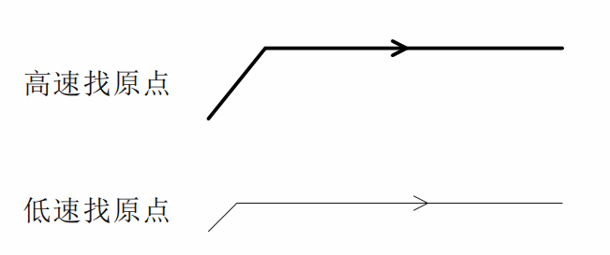
Note:In the following diagrams illustrating all zero-return methods, movement to the right is considered positive movement, and movement to the left is considered negative movement.

5.5.1 Method 17 (Negative Limit Return to Zero)
'Negative limit return to zero'The origin stop position is at the negative limit signal.
'Negative limit return to zero'The entire action can be divided into two cases, as follows:
Scenario A: The driver receives'Return to origin enable signal'After the command, with'Return speed V1''Acceleration and deceleration time back to origin'Several parameters initiate the movement, and upon encountering the rising edge of the limit signal, the system decelerates and stops. Then...'The return speed V2' moves in the opposite direction until it encounters the falling edge of the limit signal, at which point it decelerates and stops, completing the entire return-to-zero operation.
Scenario B: The driver receives...'Return to origin enable signal'If the signal is given and the device is within the limit, it will be based on...'Return speed V2''Acceleration and deceleration time back to origin'The parameters begin to move, and when they encounter the falling edge of the limit signal, they decelerate and stop, completing the entire return-to-zero operation.
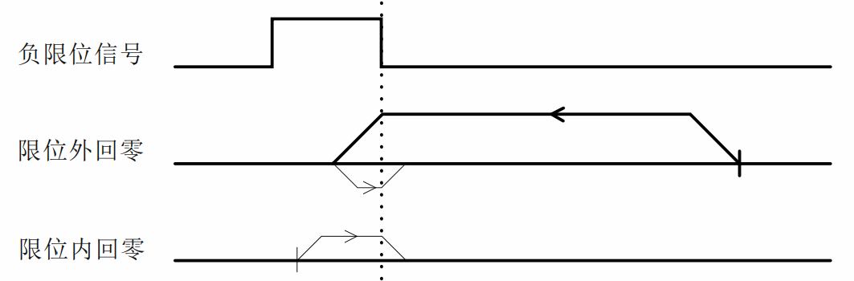

5.5.2 Method 18 (Positive Limit Return to Zero)
'Positive limit return to zero'The origin stop position is at the positive limit signal.
'Positive limit return to zero'and'Negative limit return to zero'Similar, but the direction of operation is reversed, which will not be explained in detail here.
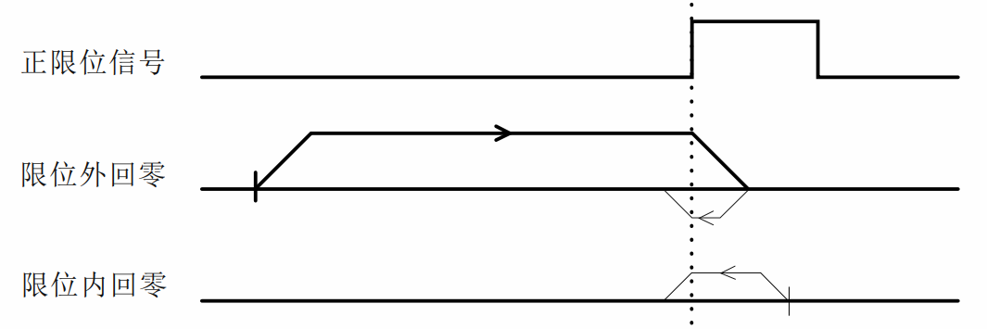

5.5.3 Method 19 (Return to Zero 1)
'The origin docking position of "origin return to zero 1'" is to the left of the rising edge of the origin signal in the positive direction.
'The entire action of returning the origin to zero (1') can be divided into two cases, as follows:
Scenario A: The driver receives'Return to origin enable signal'After the command, with'Return speed V1''Acceleration and deceleration time back to origin'Several parameters move in the positive direction, and when they encounter the rising edge of the origin signal, they decelerate and stop. Then...'The homing speed V2' moves in the opposite direction until it encounters the falling edge of the homing signal, at which point it decelerates and stops, completing the entire homing process.
Scenario B: The driver receives...'Return to origin enable signal'If the command is given and the location is within the origin signal range, then it will be executed as follows:'Return speed V2''Acceleration and deceleration time back to origin'Several parameters move in opposite directions. When they encounter the falling edge of the origin signal, they decelerate and stop, and the entire return-to-zero operation is completed.
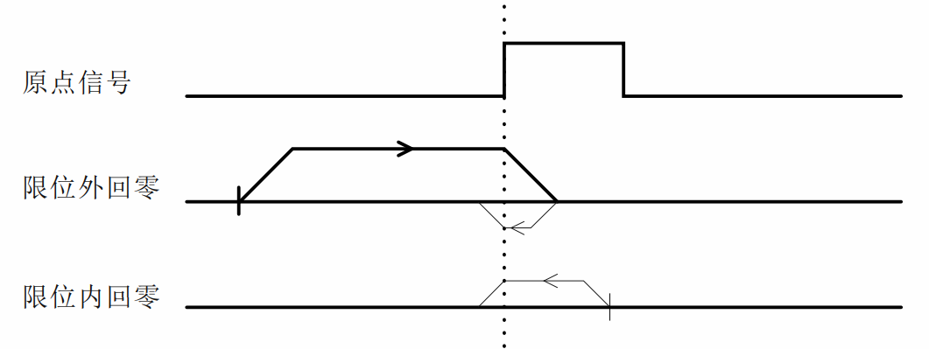

5.5.4 Method 20 (Return to Zero 2)
'The origin docking position of origin return 2' is to the right of the rising edge of the origin signal in the positive direction.
'The entire motion of returning the origin to zero (2') is shown in the diagram below. It will not be explained in detail here.
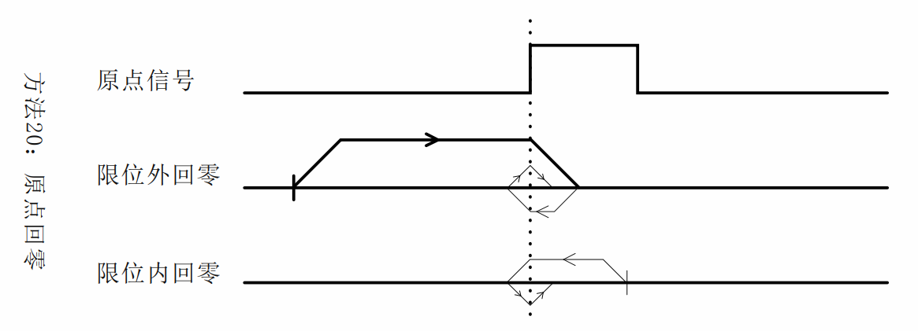

5.5.5 Method 21 (Return to Zero 3)
'The origin docking position of the origin return 3' is to the right of the rising edge of the origin signal in the opposite direction.
'The entire movement of returning to zero from the origin for 3 minutes is similar to...'The method is similar to "Returning to Zero 1", except that the initial direction of movement is reversed. Further details will not be provided here.
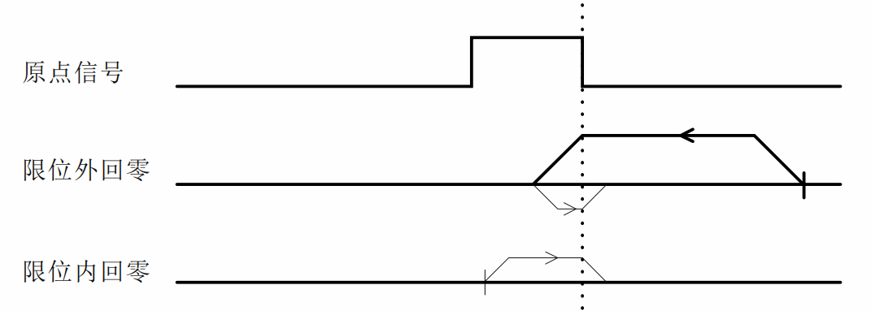

5.5.6 Method 22 (Return to Zero 4)
'The origin docking position of the origin return to zero 4' is to the left of the rising edge of the origin signal in the opposite direction.
'The entire movement of returning to zero from the origin in 4' is...'The method is similar to the "origin to zero 2'" method, except that the initial direction of movement is reversed. Further details will not be provided here.
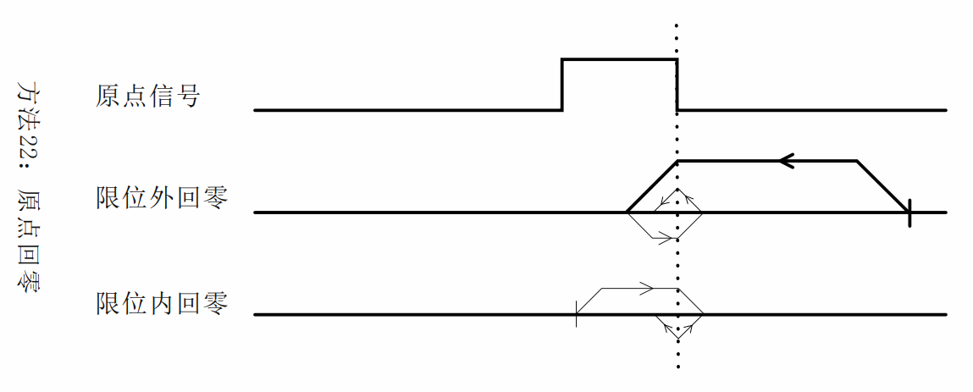

5.5.7 Method 23 (Origin + Positive Limit Switch Zeroing 1)
'The origin stop position of "origin + positive limit zeroing 1'" is to the left of the rising edge of the origin signal in the positive direction.
'The entire action of returning to zero from the origin + positive limit 1' can be divided into three cases, as follows:
Scenario A: The driver receives'Return to origin enable signal'After the command, with'Return speed V1''Acceleration and deceleration time back to origin'Several parameters move in the positive direction, and when they encounter the rising edge of the origin signal, they decelerate and stop. Then...'The homing speed V2' moves in the opposite direction until it encounters the falling edge of the homing signal, at which point it decelerates and stops, completing the entire homing process.
Scenario B: The driver receives'Return to origin enable signal'After the command, with'Return speed V1''Acceleration and deceleration time back to origin'Several parameters move in the positive direction, and stop immediately when they encounter the rising edge of the positive limit signal. Then...'The homing speed V2' moves in the opposite direction until it encounters the falling edge of the homing signal, at which point it decelerates and stops, completing the entire homing process.
Case C: The driver receives'Return to origin enable signal'If the command is given and the location is within the origin signal range, then it will be executed as follows:'Return speed V2''Acceleration and deceleration time back to origin'Several parameters move in opposite directions. When they encounter the falling edge of the origin signal, they decelerate and stop, and the entire return-to-zero operation is completed.
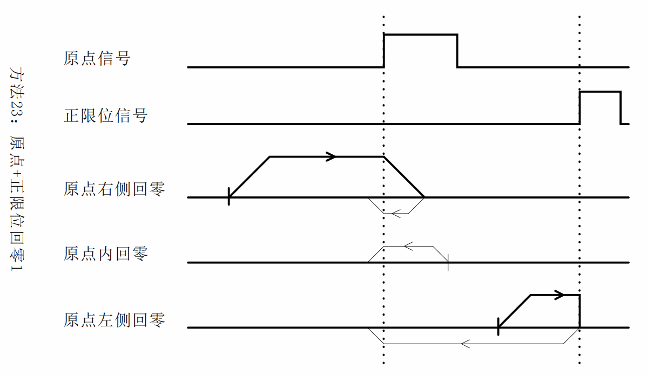

5.5.8 Method 24 (Origin + Positive Limit Switch Zeroing 2)
'The origin stop position of the origin + positive limit zeroing 2' is to the right of the rising edge of the origin signal in the positive direction.
'The entire motion of origin + positive limit return to zero 2' is shown in the figure below. It will not be explained in detail here.
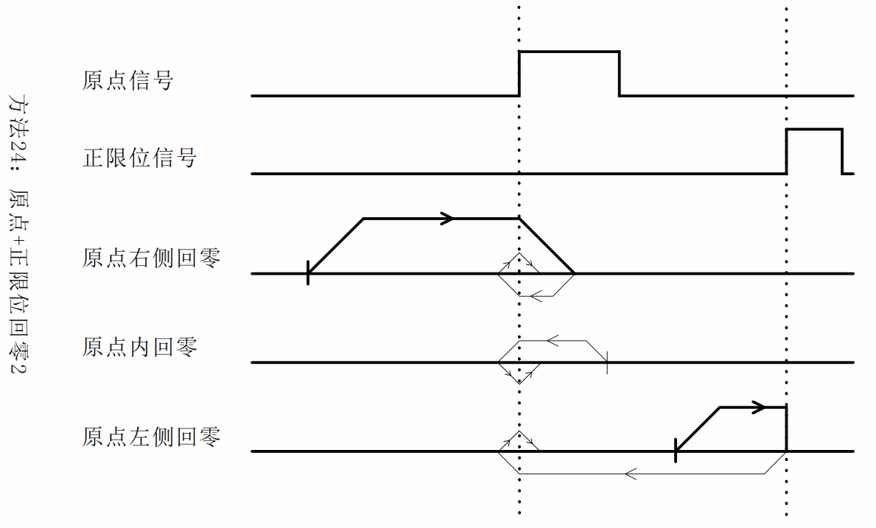

5.5.9 Method 25 (Origin + Positive Limit Switch Zeroing 3)
'The origin stop position of the origin + positive limit homing 3' is to the left of the falling edge of the origin signal in the positive direction.
'The entire action of returning to zero from the origin + positive limit 1' can be divided into three cases, as follows:
Scenario A: The driver receives'Return to origin enable signal'After the command, with'Return speed V1''Acceleration and deceleration time back to origin'Several parameters move in the positive direction, and when encountering the rising edge of the origin signal, the operation continues. When encountering the falling edge of the origin signal, the system decelerates and stops. Then...'The homing speed V2' moves in the opposite direction until it encounters the rising edge of the homing signal, at which point it decelerates and stops, completing the entire homing process.
Scenario B: The driver receives'Return to origin enable signal'After the command, with'Return speed V1''Acceleration and deceleration time back to origin'Several parameters move in the positive direction, and stop immediately when they encounter the rising edge of the positive limit signal. Then...'The homing speed V2' moves in the opposite direction until it encounters the rising edge of the homing signal, at which point it decelerates and stops, completing the entire homing process.
Case C: The driver receives'Return to origin enable signal'If the command is given and the location is within the origin signal range, then it will be executed as follows:'Return speed V1''Acceleration and deceleration time back to origin'Several parameters move in the positive direction, and when they encounter the falling edge of the origin signal, they decelerate and stop. Then...'The homing speed V2' moves in the opposite direction until it encounters the rising edge of the homing signal, at which point it decelerates and stops, completing the entire homing process.
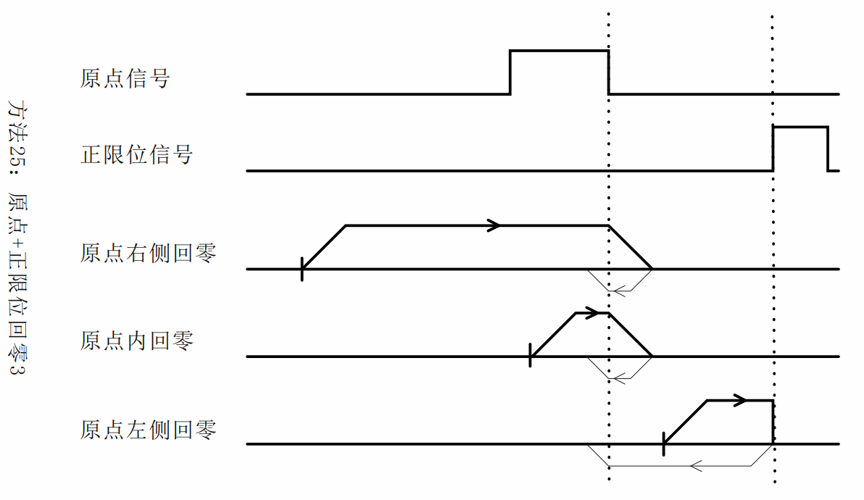

5.5.10 Method 26 (Origin + Positive Limit Switch Zeroing 4)
'The origin stop position of the origin + positive limit 4' is to the right of the falling edge of the origin signal in the positive direction.
'The entire motion of origin + positive limit return to zero 4' is shown in the figure below. It will not be explained in detail here.
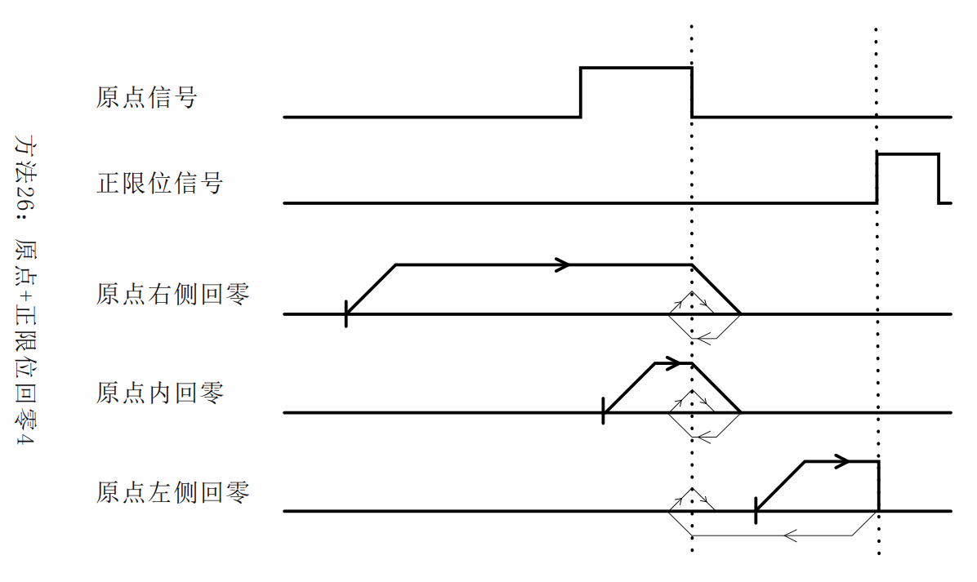

5.5.11 Method 27 (Origin + Negative Limit Return to Zero 1)
'The origin stop position of the origin + negative limit return to zero 1' is to the right of the rising edge of the origin signal in the opposite direction.
'The entire movement of origin + negative limit return to zero 1' is similar to...'The method is similar to "origin + positive limit switch return to zero 1'", except that the initial running direction is reversed. Further details will not be provided here.
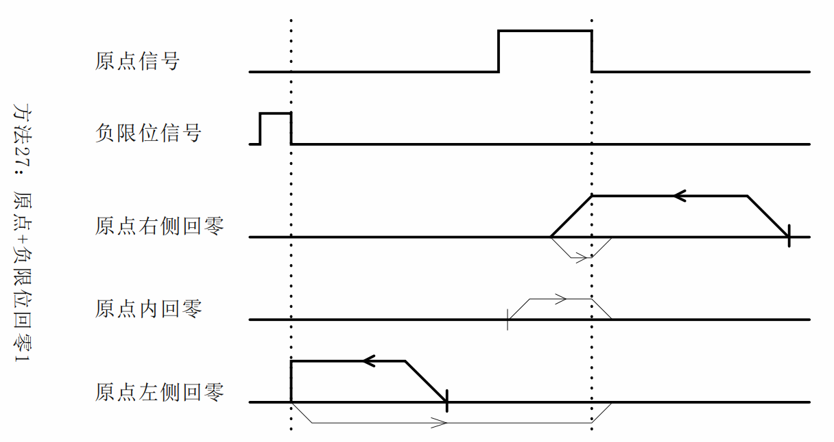

5.5.12 Method 28 (Origin + Negative Limit Return to Zero 2)
'The origin stop position of the origin + negative limit return to zero 2' is to the left of the rising edge of the origin signal in the opposite direction.
'The entire movement of origin + negative limit return to zero 2' is similar to...'The origin + positive limit switch 2' is similar, except that the initial running direction is reversed. Further details will not be provided here.
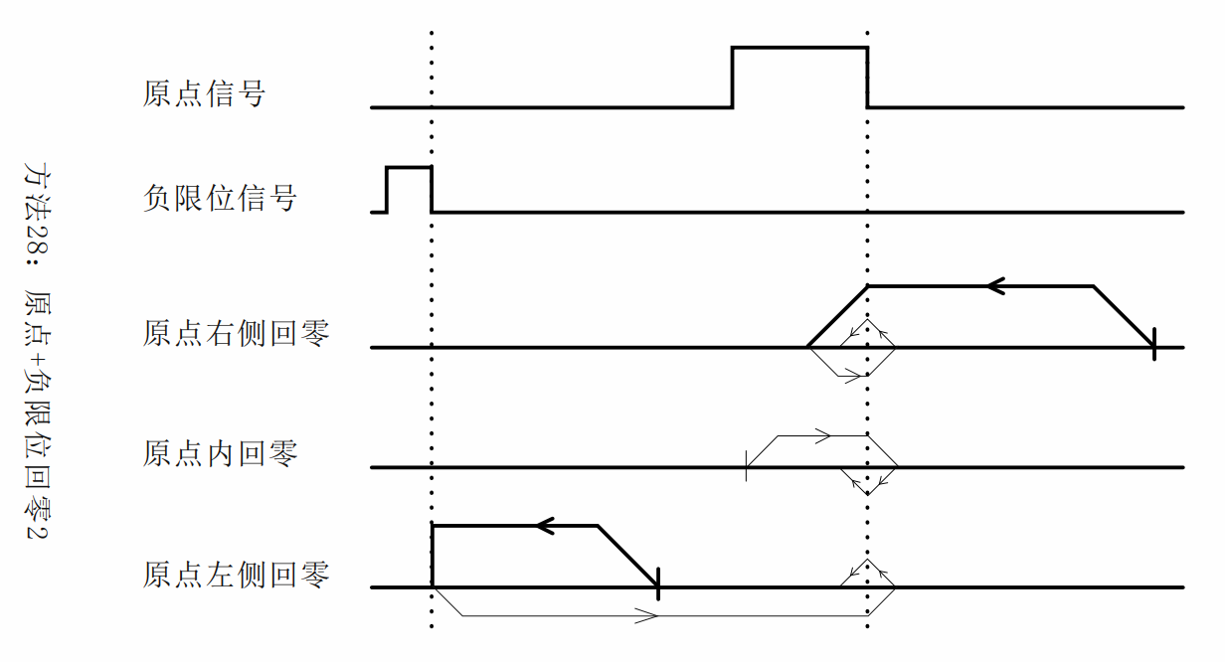

5.5.13 Method 29 (Origin + Negative Limit Return to Zero 3)
'The origin stop position of the origin + negative limit return to zero 3' is to the right of the falling edge of the origin signal in the opposite direction.
'The entire movement of returning to zero from the origin + negative limit for 3' is similar to...'The origin + positive limit switch 3' is similar, except that the initial running direction is reversed. Further details will not be provided here.
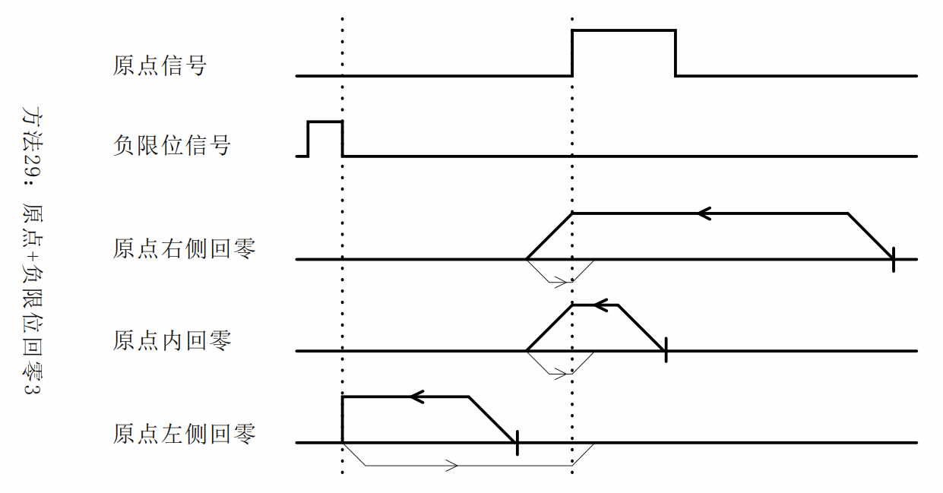

5.5.14 Method 30 (Origin + Negative Limit Return to Zero 4)
'The origin stop position of the origin + negative limit return to zero 4' is to the left of the falling edge of the origin signal in the opposite direction.
'The entire movement of returning to zero from the origin + negative limit 4' is similar to...'The origin + positive limit switch 4' is similar, except that the initial running direction is reversed. Further details will not be provided here.
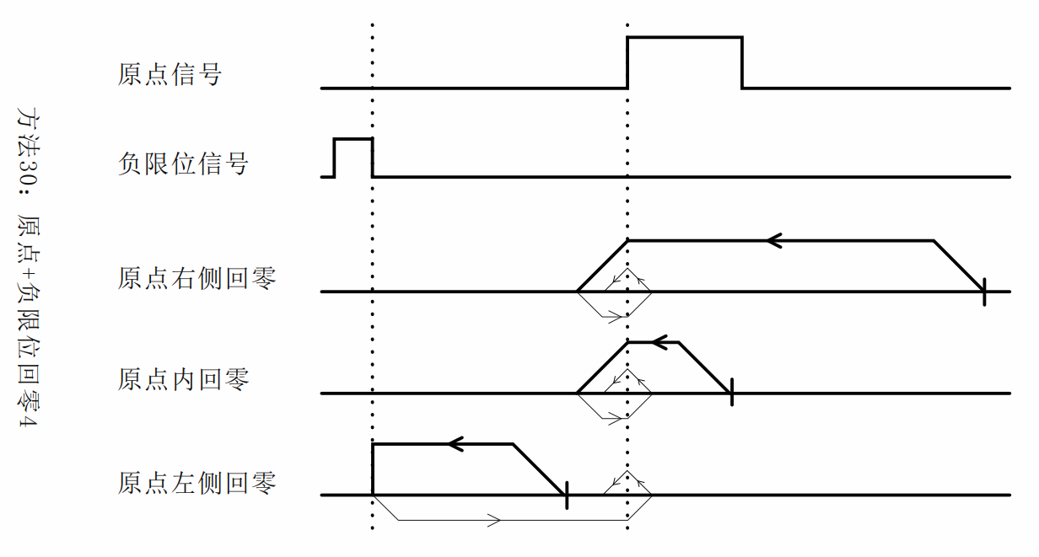

5.5.15 Method 33 (Z signal returns to zero 1)
This zero-return method uses the Z signal as the zero-return detection signal, and...'Negative limit return to zero'The directions are consistent, and the origin docking position is to the right of the Z signal.
'The entire process of the Z signal returning to zero (1') is shown in the figure below. It will not be explained in detail here.
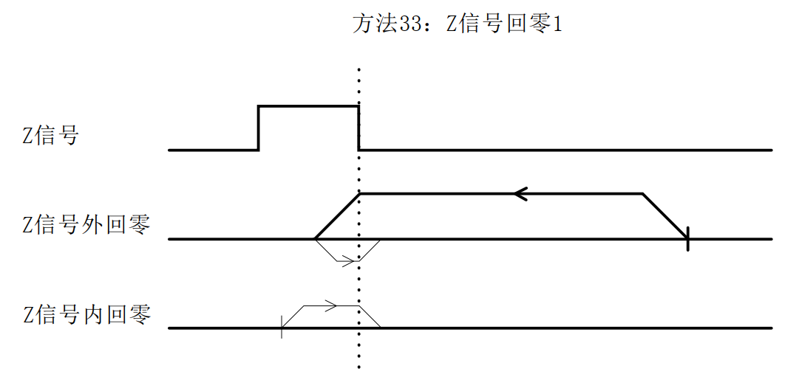

5.5.16 Method 34 (Z signal returns to zero 2)
This zero-return method uses the Z signal as the zero-return detection signal, and...'Positive limit return to zero'The directions are the same, and the origin docking position is to the left of the Z signal.
'The entire process of the Z signal returning to zero for 2' is shown in the figure below. It will not be explained in detail here.
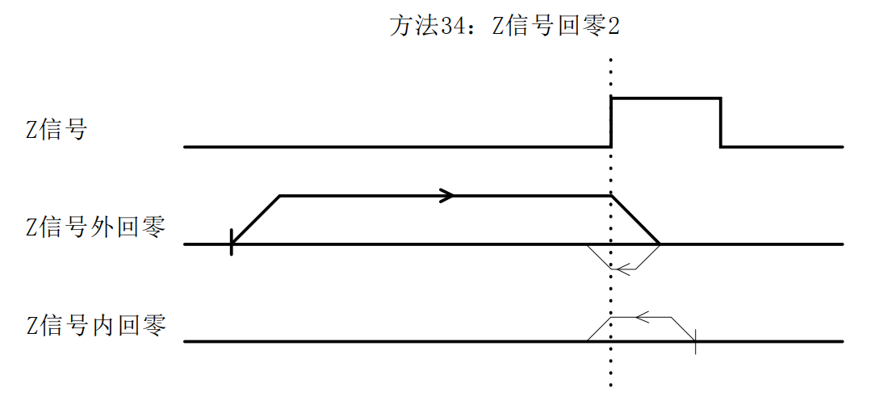

5.5.17 Method -3 (Blocked and then returned to zero 1)
The motor initially'The motor moves in the positive direction at a speed of V1' back to the origin. After stalling, it decelerates and stops, then moves in the opposite direction. After the motor's dynamic torque disappears, it decelerates to a stop and uses this position as the origin.
The entire action of this zero-mode is shown in the following diagram. It will not be explained in detail here.
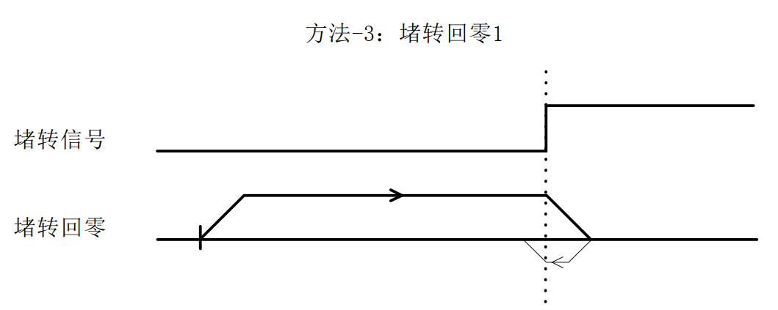

5.5.18 Method -4 (Blocked and returned to zero 2)
The motor initially'The motor runs in the opposite direction at the speed V1' back to the origin. After stalling, it decelerates and stops, then moves in the opposite direction. After the dynamic torque of the motor disappears, it decelerates to a stop and takes that position as the origin.
The entire action of this zero-mode is shown in the following diagram. It will not be explained in detail here.
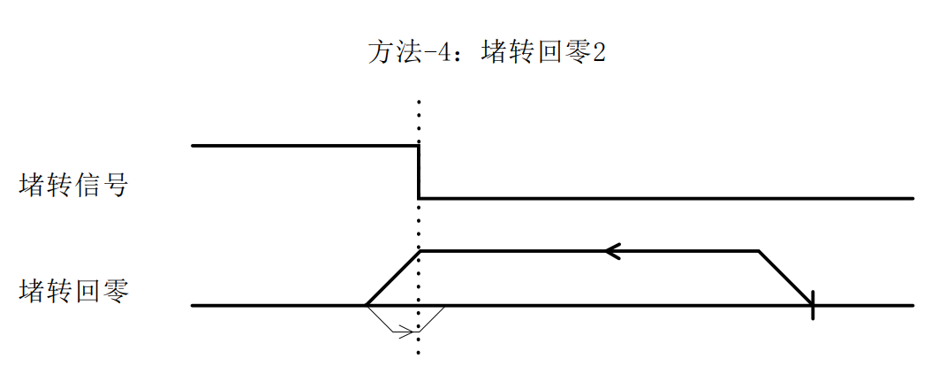

5.5.19 Method -5 (blocked and turned back to zero 3)
The motor initially'The engine runs in the positive direction at a speed of V1' back to the origin. If a stall occurs, it stops immediately, and that position is taken as the origin.
The entire action of this zero-mode is shown in the following diagram. It will not be explained in detail here.
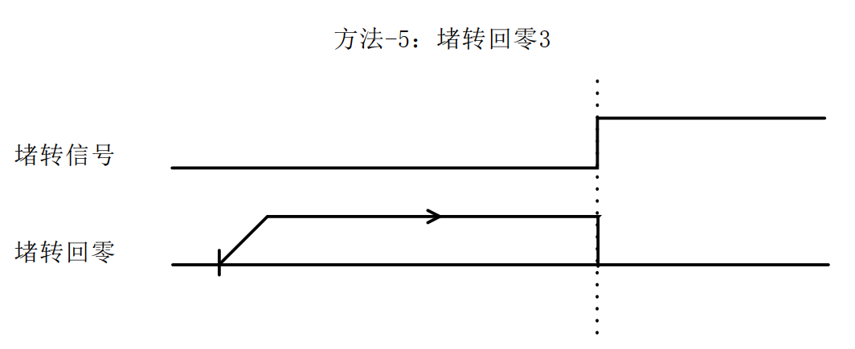

5.5.20 Method -6 (blocked and turned back to zero 4)
The motor initially'The engine runs in the opposite direction at a speed of V1' back to the origin. If a stall occurs, it stops immediately, and that position is taken as the origin.
The entire action of this zero-mode is shown in the following diagram. It will not be explained in detail here.
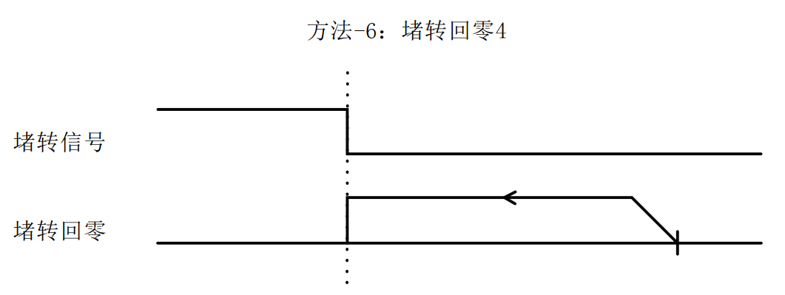

5.5.21 Brief Introduction to Other Zero-Return Methods
The above sections introduced zero-return methods 17-30, 33, 34, and (-3)-(-6). The remaining zero-return methods are similar to those described above, and the corresponding relationships are shown in the table below:
Return to zero method | Similar zeroing methods | describe
1 | 17 | After finding each positive and negative limit or the origin limit, continue running, taking the first detected Z signal as the zero point position;
2 | 18
3 | 19
4 | 20
5 | twenty one
6 | twenty two
7 | twenty three
8 | twenty four
9 | 25
10 | 26
11 | 27
12 | 28
13 | 29
14 | 30
-1 | 3
-2 | 4
35, 37 | none | Use the current position as the zero point;

Serial port download parameter description
Manufacturer parameters can be set using our company's debugging software.
Software name: MotorView_v1.0.8.02(ZX) or higher.

Fault codes and indicator lights

7.1 Driver failure
Code 603F | Code 1001 | meaning | 201C code | Cleanability | 201B Corresponding Location | LED flashing
0x2211 | 0x02 | Overcurrent fault | 0x0E0 | no | Bit0 | 1 time
0x3211 | 0x04 | Busbar overvoltage | 0x0C0 | no | Bit1 | 2 times
0x5110 | 0x80 | Phase A of the motor is missing. | 0x210 | no | Bit1 | 3 times
0x5120 | 0x80 | Phase B of the motor is missing. | 0x210 | no | Bit1 | 3 times
0x8402 | 0x20 | Command overspeed | 0x1A0 | yes | Bit2 | 4 times
0x5530 | 0x80 | Parameter saving failure | 0x240 | yes | Bit3 | 3 times
0x8403 | 0x20 | The instruction pulse increment is too large within the PWM cycle. | 0x1A1 | yes | - | 4 times
0x8401 | 0x20 | Poor location | 0x1A2 | no | - | 4 times
- | - | Hardware interrupt protection | - | - | -
Writing a 1 to 201E will clear the current alarm;
Writing 1 to 201D will clear the fault record, that is, clear the 201B fault list;

7.2 EtherCAT Communication Alarm
According to the EtherCAT ALM status code definition, the following is a partial list of error codes.
Code 603F | Code 1001 | meaning | 201C | Cleanability | LED flashing
0x8213 | 0x10 | BOOT not supported |  | 1 | 4 times
0x8215 | 0x10 | BOOT mode configuration invalid |  | 1 | 4 times
0x8216 | 0x10 | Invalid email configuration |  | 1 | 4 times
0x8217 | 0x10 | Invalid SM configuration |  | 1 | 4 times
0x821B | 0x10 | SM Watchdog Timeout | 0x101B | 1 | 4 times
0x821C | 0x10 | Invalid SM type | 0x101C | 1 | 4 times
0x821D | 0x10 | Invalid output configuration |  | 1 | 4 times
0x821E | 0x10 | Invalid input configuration |  | 1 | 4 times
0x821F | 0x10 | Invalid watchdog configuration |  | 1 | 4 times
0x821A | 0x10 | Synchronization mode error | 0x101A | 1 | 4 times
0x8230 | 0x10 | Invalid DC configuration |  | 1 | 4 times
0x8232 | 0x10 | DC PLL error | 0x1032 | 1 | 4 times
0x8233 | 0x10 | DC synchronous IO error | 0x1033 | 1 | 4 times
0x8234 | 0x10 | DC synchronization timeout | 0x1034 | 1 | 4 times
0x8211 | 0x10 | Invalid status change request | 0x1011 | 1 | 4 times
0x8212 | 0x10 | Unknown state change request | 0x1012 | 1 | 4 times
0x8221 | 0x10 | The slave station needs to enter the Init state. | 0x1021 | 1 | 4 times
0x8222 | 0x10 | The slave station needs to be in Pre-Op state. | 0x1022 | 1 | 4 times
0x8223 | 0x10 | The slave station needs to be in Safe-OP state. | 0x1023 | 1 | 4 times

Warranty and after-sales service

8.1 Warranty

8.1.1 Free Warranty Status
Our company solemnly promises that all products purchased from us will be provided with one year of free repair service if they are damaged due to their own defects during use. The round-trip shipping costs will be shared equally by both parties.

8.1.2 Cases not covered by warranty
- The driver was damaged due to incorrect wiring by the customer.
- Exceeding the rated operating voltage can damage the driver.
- Connecting a DC-powered drive to an AC power source can damage the driver.
- The driver was damaged because the customer's site environment was extremely harsh, such as humid, extremely cold, or extremely hot, and the customer did not inform the company in advance.
- The customer disassembled the drive casing without authorization, or there were signs that the serial number had been torn off.
- The casing was visibly damaged or impacted 15 days after the customer confirmed receipt, resulting in damage to the driver.
- Unavoidable natural disasters, such as fires, earthquakes, tsunamis, typhoons, etc.;
In the above situations, our company will charge a certain repair cost fee after assessing the interests of all parties. In all other situations, repairs will be provided free of charge indefinitely.

8.2 Exchange

8.2.1 Product replacement due to malfunction
For any malfunctions in the new product itself, our company offers a three-month free replacement service.
Once our technical support staff confirms the problem is with the product itself, please send the product back to our company to avoid time and postage losses during the round trip. Customers must first send the faulty product back via express delivery or logistics. Upon receiving the product, our company will send a replacement to the customer as soon as possible.
Notice:All our products undergo rigorous testing and aging before leaving the warehouse, so malfunctions of new products are extremely rare. Please read the instruction manual carefully or consult our technical support personnel before operation, or have our technical support personnel remotely assist customers in operation.
- Please note the following points when exchanging goods:
- Please ensure the packaging is intact when returning the item to avoid damage during shipping;
- When exchanging goods, please ensure that all accessories are complete;
- Each driver should be individually packaged in its original outer box to avoid secondary damage to the product during transportation;
- If the drive is returned and confirmed to be not a product malfunction but rather due to customer negligence in operation, resulting in the customer mistakenly believing the drive to be faulty, our company will not bear the shipping costs (customer negligence includes: incorrect wiring leading to drive damage, faulty wiring leading to the mistaken belief that the drive is damaged, operational errors causing the drive to malfunction, etc.).

8.2.2 Replacement for non-product malfunctions
If a customer is dissatisfied with the appearance or function of the received product and wishes to replace it with a superior driver, they can apply for an exchange within one week of receiving the product. After verification, the product will be returned to the company. The company will replace the product with another one, provided the returned product is undamaged, all accessories are complete, and the packaging is in good condition. If there is a price difference in the replacement product, the customer will be responsible for the difference.
Note: Replaced products will no longer be eligible for non-product failure exchange services. All round-trip shipping costs and other expenses incurred for non-product failure exchange services will be borne by the customer!

8.3 Returns
Our company offers a 7-day return policy for products with quality issues. If you discover any quality problems with the product within 7 days of receiving it (based on the actual date of receipt by the customer), please contact our sales representative or technical support personnel in a timely manner. After our technical support personnel confirm that the product has quality issues, the customer should send the original complete product, its inner and outer packaging, accessories, and delivery note back to our company via express delivery or logistics.
If, after our company has inspected and confirmed that there are no errors, the customer still insists on returning the goods, the customer shall bear all round-trip shipping costs and all other expenses incurred as a result.
- Please note the following points when returning goods:
(1) Please contact the relevant department of our company before proceeding with the refund process;
(2) The product must be brand new and in its original packaging. Please send it back to our company by express delivery or logistics.
(3) We will not accept complaints about product damage, missing accessories, or other issues caused by the customer.

8.4 After-sales service
If you require after-sales service support while using this product, please contact our company immediately.
Nationwide toll-free service hotline: 0755-23206995;
Technical support hotline: 18576758897 (Mr. Xie), 17666115681 (Mr. Tuo);
Service hours: Monday to Friday, 8:30-17:30 (excluding national statutory holidays).

Version Revision History
Version number | illustrate | Modify deadline | Modified by/Reviewed by
V1.0.0 | EC57-K02 Series Initial Instruction Manual Version; | 2025.3.13 | TCJ/XH

